**-- A. Pizza Metrics**

***--1 How many pizzas were ordered?***

SELECT

COUNT(*) AS total_pizzas_ordered

FROM customer_orders_clean;

**RESULT:**



* Toatal 14 pizzas were ordered

***-- 2 How many unique customer orders were made?***

SELECT

COUNT(DISTINCT customer_id) AS unique_customers

FROM customer_orders_clean;

**RESULT:**



-- 5 unique customers’ orders were made

***--3 How many successful orders were delivered by each runner?***

SELECT runner_id,COUNT(order_id) AS tot_order_delivered

FROM runner_orders_clean

WHERE distance>0

GROUP BY runner_id

ORDER BY runner_id;

**RESULT:**

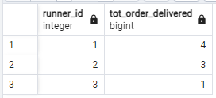

***-- 4 How many of each type of pizza was delivered?***

SELECT pn.pizza_name,COUNT(c.pizza_id) AS pizza_delivered_Number

FROM customer_orders_clean c

JOIN runner_orders_clean r

ON c.order_id=r.order_id

JOIN pizza_names pn

ON c.pizza_id=pn.pizza_id

WHERE r.distance>0

GROUP BY pn.pizza_name

ORDER BY pn.pizza_name;

**RESULT:**

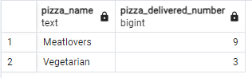

***-- 5 How many Vegetarian and Meatlovers were ordered by each customer?***

SELECT c.customer_id,pn.pizza_name,

COUNT(pn.pizza_name) AS order_count

FROM customer_orders_clean c

JOIN pizza_names pn

ON c.pizza_id=pn.pizza_id

GROUP BY c.customer_id,pn.pizza_name

ORDER BY c.customer_id

**RESULT:**

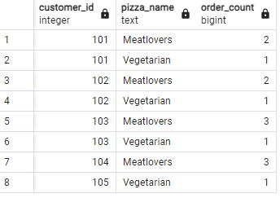

***-- 6 What was the maximum number of pizzas delivered in a single order?***

WITH count_pizza

AS

(

SELECT c.order_id,COUNT(c.pizza_id) AS pizza_count

FROM customer_orders_clean c

JOIN runner_orders_clean r

ON c.order_id=r.order_id

WHERE r.distance>0

GROUP BY c.order_id

)

SELECT MAX(pizza_count) AS pizza_count

FROM count_pizza;

**RESULT:**



***-- 7 For each customer, how many delivered pizzas had at least 1 change and how many had no changes?***

SELECT c.customer_id,

SUM(

CASE WHEN c.exclusions <> NULL OR c.extras <> NULL THEN 1

ELSE 0

END

)AS change,

SUM(

CASE

WHEN c.exclusions=NULL or c.extras=NULL THEN 1

ELSE 0

END

) AS no_change

FROM customer_orders_clean c

JOIN runner_orders_clean r

ON c.order_id=r.order_id

WHERE r.distance > 0

GROUP BY c.customer_id

ORDER BY c.customer_id;

**RESULT:**

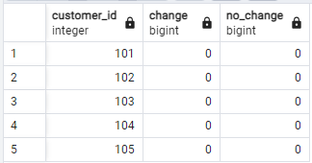

***-- 8 How many pizzas were delivered that had both exclusions and extras?***

SELECT COUNT(*) AS pizza_delivered_with_exclusions_and_extras

FROM customer_orders_clean c JOIN runner_orders_clean r

ON c.order_id=r.order_id

AND r.distance>0

WHERE c.exclusions IS NOT NULL

AND c.exclusions <> ''

AND c.extras IS NOT NULL

AND c.extras <> '';

**RESULT:**



***-- 9 What was the total volume of pizzas ordered for each hour of the day?***

SELECT EXTRACT(HOUR FROM c.order_time) AS order_hour,

COUNT(c.pizza_id) AS pizza_order_count -- CAN USE order_id both produce same result

FROM customer_orders_clean c

GROUP BY order_hour

ORDER BY order_hour;

**RESULT:**

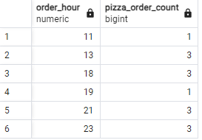

***-- 10 What was the volume of orders for each day of the week?***

SELECT

EXTRACT(DOW FROM c.order_time) AS day_number,

TO_CHAR(c.order_time,'Day') AS day_of_week,

COUNT(c.order_id) AS order_count

FROM customer_orders_clean c

GROUP BY day_number,day_of_week

ORDER BY day_number;

**RESULT:**

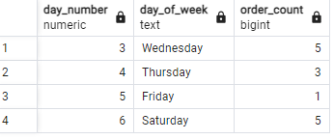

**-- B. Runner and Customer Experience**

***-- 1 How many runners signed up for each 1 week period? (i.e. week starts 2021-01-01)***

SELECT

DATE_TRUNC('week',registration_date) AS signup_week,

COUNT(runner_id) AS runner_count

FROM runners

WHERE registration_date>='2021-01-01'

GROUP BY signup_week

ORDER BY signup_week;

**RESULT:**

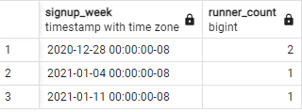

***-- 2 What was the average time in minutes it took for each runner to arrive***  ***at the Pizza Runner HQ to pickup the order?***

WITH minutes_cte AS

(

SELECT

r.runner_id,

ROUND(EXTRACT(EPOCH FROM(r.pickup_time-c.order_time))/60 )as avg_arrival_in_minutes

--EXTRACT(EPOCH FROM ...) returns the difference between two timestamps in seconds.

--It calculates the "epoch" or the number of seconds that have passed between two timestamps,

-- which can then be converted to minutes by dividing by 60.

FROM customer_orders_clean c

JOIN runner_orders_clean r

ON c.order_id=r.order_id

WHERE r.pickup_time IS NOT NULL

AND c.order_time IS NOT NULL

GROUP BY r.runner_id,r.pickup_time,c.order_time

ORDER BY avg_arrival_in_minutes

)

SELECT ROUND(avg(avg_arrival_in_minutes),2) AS avg_time_in_minutes

FROM minutes_cte;

**RESULT:**

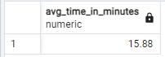

***--3 Is there any relationship between the number of pizzas and how long the order takes to prepare?***

--PIZZA & ORDER PREPARATION TIME

WITH order_preparation_time_cte

AS

(

SELECT

r.order_id,

COUNT(c.pizza_id) AS pizza_count,

EXTRACT(EPOCH FROM(r.pickup_time-c.order_time))/60 AS preparation_time_in_minutes

FROM runner_orders_clean r

JOIN customer_orders_clean c

ON r.order_id=c.order_id

AND r.distance>0

WHERE r.pickup_time IS NOT NULL

AND c.order_time IS NOT NULL

GROUP BY r.order_id,r.pickup_time,c.order_time

)

SELECT

pizza_count,

ROUND(AVG(preparation_time_in_minutes)) AVG_prep_time_minutes

FROM order_preparation_time_cte

GROUP BY pizza_count

ORDER BY pizza_count;

**RESULT:**

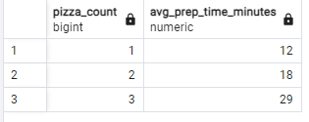

-- TO make 1 pizza=12min,3 pizza=18min,3pizza=29 min time

***-- 4 What was the average distance travelled for each customer?***

-- CUSTOMER AND DISTANCE

SELECT

c.customer_id,

ROUND(AVG(r.distance)) AS average_distance

FROM customer_orders_clean c

JOIN runner_orders_clean r

ON c.order_id=r.order_id

AND r.duration>0

GROUP BY c.customer_id

ORDER BY c.customer_id;

**RESULT:**

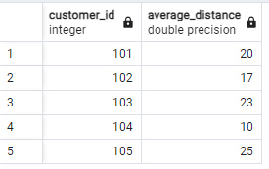

--Customer 104 stays the nearest to Pizza Runner HQ at average distance of 10km, whereas Customer 105 stays the furthest at 25km.

***-- 5 What was the difference between the longest and shortest delivery times for all orders?***

SELECT MAX(duration),MIN(duration),(MAX(duration)-MIN(duration)) delivery_time_difference

FROM runner_orders_clean

WHERE duration IS NOT NULL;

**RESULT:**



--Diff in largest and shortest delivry time is 30 min

***-- 6 What was the average speed for each runner for each delivery and do you notice any trend for these values?***

SELECT

runner_id,

order_id,

ROUND(((distance::numeric(3, 1)) /(duration::numeric(3, 1)/60)),2) as speed_km_per_hour

FROM

runner_orders_clean

WHERE

duration IS NOT NULL

ORDER BY

runner_id,

order_id;

**RESULT:**

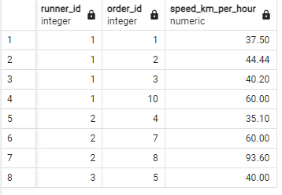

*/\**(Average speed = Distance in km / Duration in hour)

* Runner 1’s average speed runs from 37.5km/h to 60km/h.
* Runner 2’s average speed runs from 35.1km/h to 93.6km/h. Danny should investigate Runner 2 as the average speed has a 300% fluctuation rate!
* Runner 3’s average speed is 40km/h

*/

-- 7 What is the successful delivery percentage for each runner?

SELECT

runner_id,

COUNT(*) As tot_deliveries,

COUNT(

CASE WHEN duration IS NOT NULL AND pickup_time IS NOT NULL THEN 1 END

) AS successful_deliveries,

ROUND(

COUNT(

CASE WHEN duration IS NOT NULL AND pickup_time IS NOT NULL THEN 1 END

)::DECIMAL/COUNT(*)*100,2

)AS success_percentage

FROM runner_orders_clean

GROUP BY runner_id

ORDER BY success_percentage DESC;

**RESULT:**

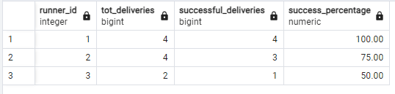

/*Runner 1 has 100% successful delivery.

Runner 2 has 75% successful delivery.

Runner 3 has 50% successful delivery*/

**--C. Ingredient Optimisation**

***-- 1 What are the standard ingredients for each pizza?***

SELECT

pn.pizza_name,

pt.topping_name

FROM

pizza_names pn JOIN pizza_recepies_clean pr

ON pn.pizza_id=pr.pizza_id

JOIN pizza_toppings pt

ON pr.topping_id=pt.topping_id

ORDER BY pn.pizza_name,pt.topping_name;

**RESULT:**

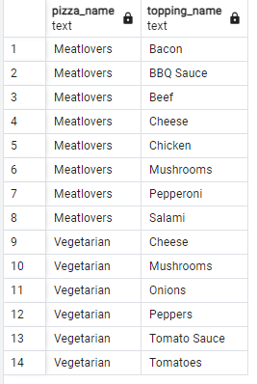

***-- 2 What was the most commonly added extra?***

WITH extras_cte AS (

SELECT

UNNEST(STRING_TO_ARRAY(extras, ','))::INTEGER AS extras_id

FROM customer_orders

WHERE extras IS NOT NULL

AND extras != ''

AND extras != 'null' -- Exclude any 'null' strings

)

SELECT

e.extras_id,

pt.topping_name AS extras_name,

COUNT(e.extras_id) AS extras_count

FROM extras_cte e

JOIN pizza_toppings pt

ON e.extras_id = pt.topping_id

GROUP BY e.extras_id,pt.topping_name

ORDER BY extras_count DESC

--LIMIT 1;

**RESULT:**

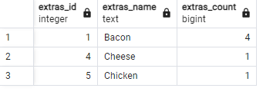

--most common added extra is bacon which count =4

***-- 3 What was the most common exclusion?***

WITH exclusion_cte AS (

SELECT

UNNEST(STRING_TO_ARRAY(exclusions, ','))::INTEGER AS exclusion_id

FROM customer_orders

WHERE exclusions IS NOT NULL

AND exclusions != ''

AND exclusions != 'null' -- Exclude any 'null' strings

)

SELECT

e.exclusion_id,

pt.topping_name AS exclusion_name,

COUNT(e.exclusion_id) AS exclusion_count

FROM exclusion_cte e

JOIN pizza_toppings pt

ON e.exclusion_id = pt.topping_id

GROUP BY e.exclusion_id,pt.topping_name

ORDER BY exclusion_count DESC

--LIMIT 1;

**RESULT:**

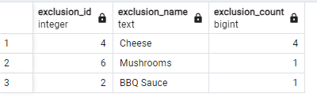

--most common exclusion is chees.

***-- 4 Generate an order item for each record in the customers_orders table***

*--in the format of one of the following:*

*--Meat Lovers*

*--Meat Lovers - Exclude Beef*

*--Meat Lovers - Extra Bacon*

*--Meat Lovers - Exclude Cheese, Bacon - Extra Mushroom, Peppers*

WITH exclusions_cte AS

(

SELECT

c.order_id,

c.pizza_id,

pt.topping_id,

pt.topping_name

FROM customer_orders_clean c

JOIN pizza_toppings pt

ON topping_id=ANY(STRING_TO_ARRAY(c.exclusions,',')::INT[])

),

extras_cte AS

(

SELECT

c.order_id,

c.pizza_id,

pt.topping_id,

pt.topping_name

FROM customer_orders_clean c

JOIN pizza_toppings pt

ON topping_id=ANY(STRING_TO_ARRAY(c.extras,',')::INT[])

),

orders_cte AS (

SELECT

DISTINCT c.order_id,

c.pizza_id,

pr.topping_id

FROM customer_orders_clean c

INNER JOIN pizza_recepies_clean pr

ON c.pizza_id=pr.pizza_id

),

orders_with_extras_and_exclusions_cte AS

(

SELECT o.order_id,o.pizza_id,

CASE WHEN o.pizza_id=1 THEN 'Meat Lovers'

WHEN o.pizza_id=2 THEN pn.pizza_name

END AS pizza_names,

STRING_AGG(DISTINCT ext.topping_name,',') AS extras,

STRING_AGG(DISTINCT excl.topping_name,',') AS exclusions

FROM orders_cte o

LEFT JOIN extras_cte ext

ON ext.order_id=o.order_id AND ext.pizza_id=o.pizza_id

LEFT JOIN exclusions_cte excl

ON excl.order_id=o.order_id AND excl.pizza_id=o.pizza_id AND excl.topping_id=o.topping_id

INNER JOIN pizza_names pn

ON o.pizza_id=pn.pizza_id

GROUP BY o.order_id,o.pizza_id,pizza_names

)

SELECT

order_id,

pizza_id,

CONCAT(pizza_names,

CASE WHEN exclusions='' THEN '' ELSE '-Exclude'|| exclusions END,

CASE WHEN extras='' THEN '' ELSE '-Extras'||extras END) AS order_item

FROM orders_with_extras_and_exclusions_cte

ORDER BY order_id;

**RESULT:**

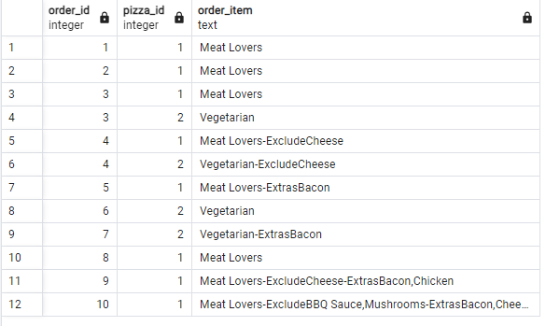

***-- 5 Generate an alphabetically ordered comma separated ingredient list***

***--for each pizza order from the customer_orders table and add a 2x in front of any relevant ingredients***

*--For example: "Meat Lovers: 2xBacon, Beef, ... , Salami"*

WITH exclusions_cte AS

(

SELECT

c.order_id,

c.pizza_id,

pt.topping_id,

pt.topping_name

FROM customer_orders_clean c

JOIN pizza_toppings pt

ON topping_id=ANY(STRING_TO_ARRAY(c.exclusions,',')::INT[])

),

extras_cte AS

(

SELECT

c.order_id,

c.pizza_id,

pt.topping_id,

pt.topping_name

FROM customer_orders_clean c

JOIN pizza_toppings pt

ON topping_id=ANY(STRING_TO_ARRAY(c.extras,',')::INT[])

),

orders_cte AS (

SELECT

DISTINCT c.order_id,

c.pizza_id,

pr.topping_id,

pt.topping_name

FROM customer_orders_clean c

INNER JOIN pizza_recepies_clean pr

ON c.pizza_id=pr.pizza_id

LEFT JOIN pizza_toppings pt

ON pr.topping_id=pt.topping_id

),

orders_with_extras_and_exclusions_cte AS

(

SELECT

O.order_id,

O.pizza_id,

O.topping_id,

o.topping_name

FROM orders_cte AS O

LEFT JOIN exclusions_cte AS excl

ON excl.order_id=o.order_id

AND excl.pizza_id=o.pizza_id

AND excl.topping_id=o.topping_id

WHERE excl.topping_id IS NULL

UNION ALL

SELECT

ext.order_id,

ext.pizza_id,

ext.topping_id,

ext.topping_name

FROM extras_cte ext

WHERE ext.topping_id IS NOT NULL

),

count_topping_cte AS

(

SELECT o.order_id,

o.pizza_id,

o.topping_name,

count(*) AS n

FROM orders_with_extras_and_exclusions_cte AS o

GROUP BY o.order_id,o.pizza_id,o.topping_name

)

SELECT

order_id,

pizza_id,

STRING_AGG(

CASE WHEN n>1 THEN n ||'x'||topping_name

ELSE topping_name

END,' , ') AS ingredient

FROM count_topping_cte

GROUP BY order_id,pizza_id;

**RESULT:**

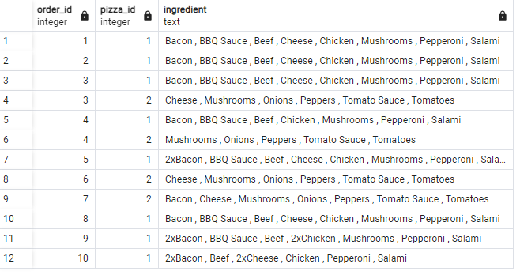

***-- 6 What is the total quantity of each ingredient used in all delivered pizza sorted by most frequent first?***

WITH exclusions_cte AS

(

SELECT

c.order_id,

c.pizza_id,

pt.topping_id,

pt.topping_name

FROM customer_orders_clean c

JOIN pizza_toppings pt

ON topping_id=ANY(STRING_TO_ARRAY(c.exclusions,',')::INT[])

),

extras_cte AS

(

SELECT

c.order_id,

c.pizza_id,

pt.topping_id,

pt.topping_name

FROM customer_orders_clean c

JOIN pizza_toppings pt

ON topping_id=ANY(STRING_TO_ARRAY(c.extras,',')::INT[])

),

orders_cte AS (

SELECT

DISTINCT c.order_id,

c.pizza_id,

pr.topping_id,

pt.topping_name

FROM customer_orders_clean c

INNER JOIN pizza_recepies_clean pr

ON c.pizza_id=pr.pizza_id

LEFT JOIN pizza_toppings pt

ON pr.topping_id=pt.topping_id

),

orders_with_extras_and_exclusions_cte AS

( SELECT

O.order_id,

O.pizza_id,

O.topping_id,

o.topping_name

FROM orders_cte AS O

LEFT JOIN exclusions_cte AS excl

ON excl.order_id=o.order_id

AND excl.pizza_id=o.pizza_id

AND excl.topping_id=o.topping_id

WHERE excl.topping_id IS NULL

UNION ALL

SELECT

ext.order_id,

ext.pizza_id,

ext.topping_id,

ext.topping_name

FROM extras_cte ext

WHERE ext.topping_id IS NOT NULL

)

SELECT

oc.topping_name,

COUNT(oc.pizza_id) AS ingredient_count

FROM orders_with_extras_and_exclusions_cte AS oc

INNER JOIN runner_orders_clean AS r

ON oc.order_id=r.order_id

WHERE pickup_time IS NOT NULL

GROUP BY oc.topping_name

ORDER BY COUNT(oc.pizza_id) DESC;

**RESULT:**

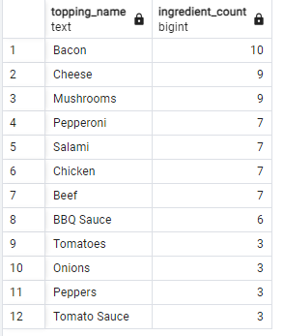

**--D. Pricing and Ratings**

***-- 1 If a Meat Lovers pizza costs $12 and Vegetarian costs $10 and there were no charges for changes how much money has Pizza Runner made so far if there are no delivery fees?***

WITH pizza_prices AS

(

SELECT 'Meatlovers' AS pizza_name, 12 AS price

UNION ALL

SELECT 'vegetarian',10

)

SELECT SUM(p.price) AS total_price

FROM customer_orders_clean c

JOIN pizza_names pn

ON c.pizza_id=pn.pizza_id

JOIN pizza_prices p

ON pn.pizza_name=p.pizza_name

WHERE

c.order_id NOT IN(

SELECT r.order_id

FROM runner_orders_clean r

WHERE r.cancellation IS NOT NULL

);

**RESULT:**



***-- 2 What if there was an additional $1 charge for any pizza extras? Add cheese is $1 extra***

WITH pizza_prices AS

(

SELECT 'Meatlovers' AS pizza_name, 12 AS price

UNION ALL

SELECT 'vegetarian',10

),

extra_cost_cte AS

(

SELECT c.order_id,

c.pizza_id,

COALESCE(extra_count.extra_cost,0) AS extra_cost

FROM customer_orders_clean c

LEFT JOIN LATERAL

(

--split the extras and count num of extras

SELECT COUNT(*) AS extra_cost

FROM UNNEST(STRING_TO_ARRAY(c.extras,',')) AS extra

WHERE c.extras IS NOT NULL AND c.extras <>''

) AS extra_count

ON TRUE

)

SELECT SUM(p.price+ec.extra_cost) AS total_cost

FROM customer_orders_clean c

JOIN pizza_names pn

ON c.pizza_id=pn.pizza_id

JOIN pizza_prices p

ON pn.pizza_name=p.pizza_name

JOIN extra_cost_cte ec

ON c.order_id=ec.order_id

WHERE

c.order_id NOT IN(

SELECT r.order_id

FROM runner_orders_clean r

WHERE r.cancellation IS NOT NULL

);

**RESULT:**

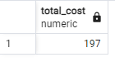

***-- 3 The Pizza Runner team now wants to add an additional ratings system that allows customers to rate their runner, how would you design an additional table for this new dataset generate a schema for this new table and***

***insert your own data for ratings for each successful customer order between 1 to 5.***

CREATE TABLE runner_ratings (

rating_id SERIAL PRIMARY KEY,

order_id INTEGER NOT NULL,

runner_id INTEGER NOT NULL CHECK(runner_id BETWEEN 1 AND 4),

rating INTEGER CHECK (rating >= 1 AND rating <= 5),

comment TEXT,

rating_date TIMESTAMP DEFAULT CURRENT_TIMESTAMP

);

INSERT INTO runner_ratings (order_id, runner_id, rating, comment)

VALUES

(1, 1, 5, 'The runner was very prompt and friendly!'),

(2, 1, 4, 'Great service, but a bit delayed.'),

(3, 2, 5, 'Perfect delivery, thank you!'),

(4, 2, 3, 'The delivery was okay, but the runner was not very polite.'),

(5, 3, 4, 'Good service overall, will order again.'),

(6, 3, 5, 'Outstanding delivery experience!'),

(7, 2, 4, 'The runner was quick but forgot my drink.'),

(8, 2, 5, 'Excellent, very satisfied with the service.'),

(9, 1, 3, 'It was fine, but nothing special.'),

(10, 1, 4, 'The runner was nice and on time, thanks!');

SELECT * FROM runner_ratings;

**RESULT:**

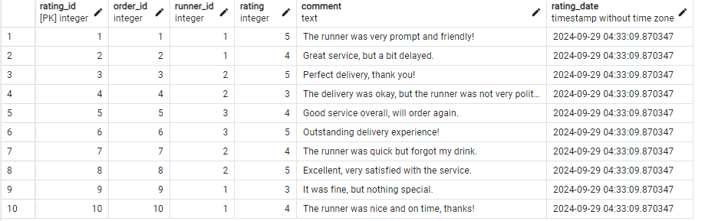

***-- 4 Using your newly generated table - can you join all of the information together to form a table***

***--which has the following information for successful deliveries?***

*--customer_id*

*--order_id*

*--runner_id*

*--rating*

*--order_time*

*--pickup_time*

*--Time between order and pickup*

*--Delivery duration*

*--Average speed*

*--Total number of pizzas*

WITH delivery_info_cte AS

(

SELECT c.customer_id,

c.order_id,

r.runner_id,

rr.rating,

c.order_time,

r.pickup_time,

-- Calculate time between order and pickup

ROUND(EXTRACT(EPOCH FROM(r.pickup_time-c.order_time))/60,2)||' min' AS time_between_order_and_pickup,

r.duration||' min' AS delivery_duration_in_minutes,

-- Calculate average speed assuming distance is in km

CASE WHEN r.distance IS NOT NULL AND r.distance>0 THEN

ROUND((r.distance::FLOAT/r.duration*60))||'km/hr'

END AS average_speed,

COUNT(c.pizza_id) AS total_pizzas

FROM

customer_orders_clean c

JOIN

runner_orders_clean r ON c.order_id = r.order_id

LEFT JOIN

runner_ratings rr ON c.order_id = rr.order_id

WHERE

r.cancellation IS NULL -- Make sure the order is successful

GROUP BY

c.customer_id, c.order_id, r.runner_id, rr.rating,

c.order_time, r.pickup_time, r.duration, r.distance

)

SELECT *

FROM delivery_info_cte

ORDER BY order_id; -- Order by order_id for better readability

**RESULT:**

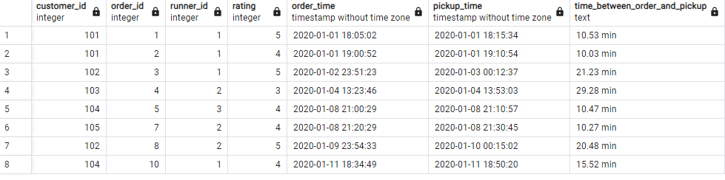

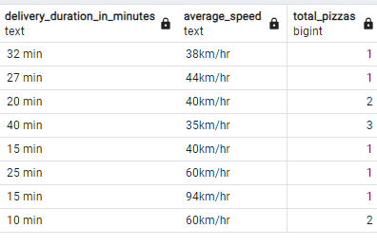

***--5 If a Meat Lovers pizza was $12 and Vegetarian $10 fixed prices with no cost for extras and each runner is paid $0.30 per kilometre traveled - how much money does Pizza Runner have left over after these deliveries?***

WITH pizza_sales AS (

SELECT

c.pizza_id,

p.pizza_name,

COUNT(*) AS pizza_count,

CASE

WHEN p.pizza_name = 'Meatlovers' THEN COUNT(*) * 12

WHEN p.pizza_name = 'Vegetarian' THEN COUNT(*) * 10

END AS total_revenue

FROM customer_orders_clean c

JOIN pizza_names p ON c.pizza_id = p.pizza_id

GROUP BY c.pizza_id, p.pizza_name

), runner_costs AS (

SELECT

order_id,

runner_id,

COALESCE( distance_in_km, 0)::NUMERIC AS distance_km

FROM runner_orders_clean

WHERE cancellation IS NULL -- Only include non-canceled orders

)

SELECT

(SELECT SUM(total_revenue) FROM pizza_sales) --revenue calculation

-

(SELECT SUM(distance_km) * 0.30 FROM runner_costs)--runner cost calculation

AS profit_left_over;

**RESULT:**

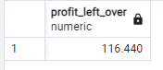

**--E. Bonus Questions**

***--If Danny wants to expand his range of pizzas - how would this impact the existing data design?***

***--Write an INSERT statement to demonstrate what would happen if a new Supreme pizza***

***--with all the toppings was added to the Pizza Runner menu?***

-- Insert into pizza_names

INSERT INTO pizza_names (pizza_id, pizza_name)

VALUES (3, 'Supreme');

-- Insert into pizza_recipes with all toppings

INSERT INTO pizza_recipes (pizza_id, toppings)

VALUES (3, '1, 2, 3, 4, 5, 6, 7, 8, 9, 10, 11, 12');

SELECT * FROM pizza_names;

**RESULT:**

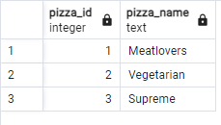

SELECT * FROM pizza_recipes;

**RESULT:**

